**Microprocessor Lab Report (Assignment - 3)**

Bisakh Mondal 001810501079

Format: Question | Assembly Code (Memory Address, OpCode, Mnemonics, Comments)

(* The programs run in simulator seamlessly, though while running into 8085 it's better to use **RST5** instead of **HLT** to return the control to monitor program, without stopping the processor by **HLT**)

**(Q1)** A set of N data bytes is stored in m/m locations starting from 2501H. The value of N is stored in 2500H, Write a program to store this data byte from m/m 2600H if D0 or D1 is 1; otherwise reject the data byte.

|  |
| --- |
| 2200 21 00 025 LXI H, 2500H; Store the starting address 2500H in HL register pair.  2203 56 MOV D, M; Move the Content pointed by HL pair to D register. (N)   2204 23 INX H; Increment H, The consecutive numbers. 2205 01 00 026 LXI B, 2600H; Store the starting address 2600H in BC register pair.    2208 7E LOOP: MOV A, M; Move the value (HL) into Accumulator. 2209 E6 81 ANI 081H; AND Immediate with 81H i.e 128+1 (D7 and D0 set bit)   220B CA 11 22 JZ NOSETBIT; If zero flag is set then neither two bits were set.    ; If Not store the value into memory location pointed by BC pair 220E 7E MOV A, M; 220F 02 STAX B; 2210 03 INX B   2211 23 NOSETBIT: INX H; Increment H 2212 15 DCR D; Decrease D 2213 C2 08 022 JNZ LOOP; Zero Flag Set, close loop   2216 76 HLT |

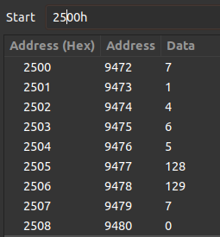 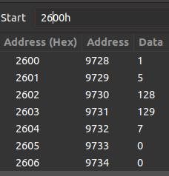

**(Q2)** There are N data Bytes stored from m/m location 2200H, the value of N is Stored in 21FFH, Write a program to find the sum of numbers whose LSB and MSB is 1, Store the result in 2500H and 2501H.

|  |
| --- |
| LXI H, 2200H; Store the starting address 2200H in HL register pair.   LDA 21FFH; Load Accumulator with N(number of elements)  MOV B, A; Move Acc with B, i.e loading the loop counter MVI C, 00; For Carry MVI D, 00; For Sum MVI E, 081H; To compare to check if both bits are set ; 81H i.e 128+1 (D7 and D0 set bit)  LOOP: MOV A, M; Move the content pointed by HL pair to Acc ANA E; And Immediate with 81H (reason stated above)  CMP E; Compare with 81H, if both bits are set after and Operation. JNZ NOSETBIT; If No zero flag they are not equal ; Sum  MOV A,D; ADD M; JNC NOCARRY; Checking for carry. INR C; NOCARRY: MOV D,A;  NOSETBIT: INX H; Increment H DCR B; Decrease B the loop counter.  JNZ LOOP; If zero flag is set, stop Looping  ; Storing sum through dumping through HL pair. MOV L, D; MOV H, C; SHLD 2500H; HLT |

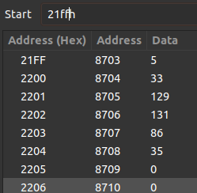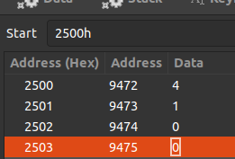

**(Q3)** Write an 8085 Program to generate Nth Fibonacci numbers **using function** and store it in 2050H. The value of N is stored in 2060H.

|  |
| --- |
| 2200 21 60 20 LXI H, 2060H; Store memory location 2060H in HL pair(the location contains N).   2203 CD 0B 022 CALL FIB; The Subroutine FIB is going to be executed.  2206 7D MOV A, L; Move content of Register L to Accumulator(which got stored during function Execution). 2207 32 50 20 STA 2050H; Store the Ans in 2050H 220A 76 HLT ; Stop execution.  ;fib function for evaluating fib sequence 220B 0E 00 FIB: MVI C, 00H; Initiate C register with 0H for fib seq calculation. 220D 16 01 MVI D, 01H; Initiate D register with 1H for fib seq calculation. 220F 46 MOV B, M; move Current N to B register.  ; calculation D=C+D and C = OLD_D  2210 79 LOOP: MOV A, C;  2211 82 ADD D; 2212 4A MOV C, D; 2213 57 MOV D,A; 2214 05 DCR B;  2215 C2 10 22 JNZ LOOP; Looping till N.   2218 69 MOV L,C; Loading the Ans to L register of HL Pair. 2219 C9 RET ; Return from Subroutine. |

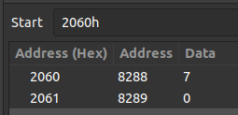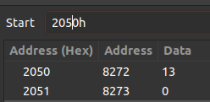

**(Q4)** Write a function to transfer a block of bytes of size N from location 1 to location 2 (location 2 > location 1) when the size of overlap between the two locations is defined by M, the values of N and M are stored in 201EH and 201FH respectively.

|  |
| --- |
| 2200 21 00 022 LXI H, 2200H; Store the location 1 into HL register pair. 2203 11 04 022 LXI D, 2204H; Store the location 2 into DE register pair. 2206 3A 1E 20 LDA 201EH; Load N (number of bytes) in Accumulator. 2209 4F MOV C, A; Move N (bytes data) to C register. 220A 06 00 MVI B,00H; Clearing B with 00 for DAD. 220C 09 DAD B; shifting HL pair to N bytes ( Double Add) 220D EB XCHG; Interchange HL and DE pair contents 220E 09 DAD B; Shifting 220F EB XCHG; re interchange  ;approach, copy from end to start to rewrite the overlap.  ; but both HL pair & DL pair points required loc +1 2210 2B DCX H; 2211 1B DCX D;    ;copying from the end to the start. 2212 7E LOOP: MOV A, M; 2213 12 STAX D; 2214 2B DCX H; 2215 1B DCX D; 2216 0D DCR C; 2217 C2 12 22 JNZ LOOP;  ; copy Done. 221A 76 HLT; |

